Ekbana SOLUTIONS  KUPONDOL

**requirement documentation of immigration nepal**

Table of Content

**1.** **Introduction** 1

**1.1 Purpose and Scope:** 1

**2.** **Feature Description** 1

**2.1** **User Authentication:** 1

**2.2** **Scan Passport:** 1

**2.3** **Scan Other Document:** 1

**2.4** **Scan Image:** 1

**2.5** **Check Blacklist:** 2

**2.6** **Offload/ Refuse entry:** 2

**2.7** **Check offload / Refuse entry:** 2

**3.** **Device used:** 2

**4.** **Required Diagrams:** 3

**4.1** **Flowchart:** 3

**5.** **Technical Specifications:** 4

# **Introduction**

## **1.1 Purpose and Scope:**

Immigration Nepal is a system which is uses to scan passports and other travel documents in the airport. The passport scanning is done by synchronizing the system with a passport scanning device. The main purpose of the system is to scan the passport or other documents provided while travelling and store the information in a database for security and future use. The system should also indicate the custom officer if there are any abnormalities in the passport provided by the travelers. The abnormalities include blacklisted person, duplicate passport, fake passport.

# **Feature Description**

The system will have the following features:

## **User Authentication:**

The system will authenticate the users. There will be a login module where the users enter their username and password. All the users should have a unique username and password. This feature is for the security of the user.

## **Scan Passport:**

The main purpose of the system is to scan the passport. Passports will be of two type one is MRZ (Machine readable passport) and non MRZ (Non Machine readable passport). As the MRZ passport is placed in the passport scanner it should display all the information of the person’s passport in the screen. The information includes document type, first name, last name, passport number, country, date of birth, gender, id, NPC (for departure), LPC (for arrival) and checksum. If all the information in the scanned document are correct then the system should display a “Passport valid” message. All the information should be saved in the data base. Similarly, if a Non MRZ passport is entered in the device then the UI should be changed and the customer office should be able to enter the required information in the system and submit it.

## **Scan Other Document:**

Besides passport the system will scan citizenship, ration card, travel document, election card, student card, majested card, PAN card and other cards. The UI of the system should change according to the document inserted in the device. If any other document except passport is enter in the device, then the UI of the system should change and the fields should be able to be entered manually. The fields include document type, first name, document number, country and check sum. The system should also save the image of the document entered.

## **Scan Image:**

While scanning the document the system should also save the image of the document provided. The system should take 3 type of images which are White light image, infrared image and Ultraviolet (UV) image. The images should be saved along with the information in the database.

## **Check Blacklist:**

As the system scans the passport it should also check if the scanned passport is listed in the blacklist. The blacklist is maintained in the central server and also locally in the user’s computer. The local database is synchronized with the central database every 15 minutes. If the scanned passport is listed in the blacklist, then the system should display a warning message. Then the custom office will take the necessary steps.

## **Offload/ Refuse entry:**

If the documents provided by the traveler is not sufficient or not valid then it traveler will be offloaded in case of departure and reuse entry in case of arrival. The offloaded or refused entry data should be saved in the database for future reference. The reasons for offload/ entry refuse may be duplicate document, blacklist document, not sufficient document etc.

## **Check offload / Refuse entry:**

If a previously offloaded or entry refused passport is scanned again then the system should show the message to the custom officer. Then the custom officer will check the reason for previous offload/entry refuse by contacting the operator before letting the traveler through.

# **Device used:**

Currently there are two device provided. The model number of the devices are as listed below:

1. OCR640e7
2. Prmc123r

# **Required Diagrams:**

## **Flowchart:**

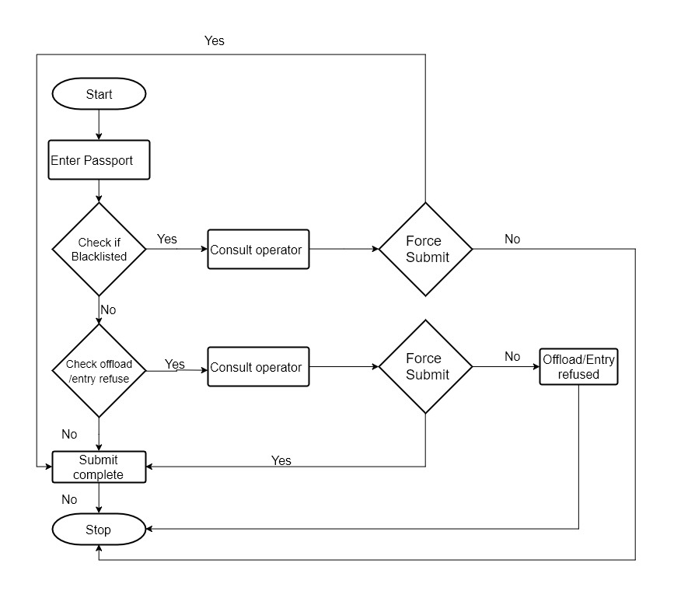

**Figure 1: Flowchart of document scan**

# **Technical Specifications:**

|  |  |
| --- | --- |
| **Specification** | **Backend** |
| **Programming Language** | C# |
| **Framework** | .Net framework 3.5 |
| **UI Framework** | WPF, windows form |
| **Database** | TBD |